DY620 Optional Engines

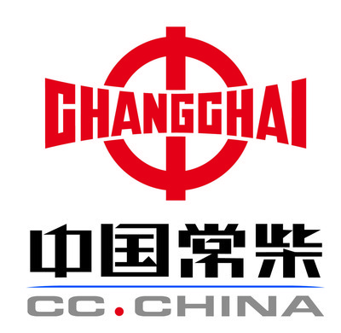  Engine brand | Chinese Changchai 3M78
Standard | China National Standard
Cooling system | Water cooling
Cylinders | 3 Cylinders
Rated Power | 16KW (22HP)
R.P.M. | 2800r/min
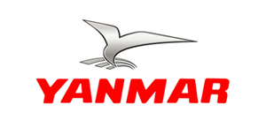
Engine brand | Yanmar 3TNV76
Standard | EURO III
Cooling system | Water cooling
Cylinders | 3 Cylinders
Rated power | 18.7KW (25HP)
R.P.M. | 3200 r/min

Engine brand | Yanmar 3TNV82A
Standard | EURO III
Cooling system | Water cooling
Cylinders | 3 Cylinders
Rated power | 22.2KW
R.P.M. | 3000r/min

Engine brand | Yanmar 3TNV74F
Standard | Terminal EPA Tier 4
Cooling system | Water cooling
Cylinders | 3 Cylinders
Rated power | 14.6KW (20HP)
R.P.M. | 3000 r/min

Model | DY620
Dimension (LxWxH) | 2195mm*980mm*2150mm
Max. reach(boom extended) | 2750mm
Max. reach(boom retracted) | 2480mm
Bucket capacity | 300L
Rated loading capacity | 500kg-800kg
Min. turning radius | 1980mm
Turning angle | 40 Degree
Speed | 10km/h
Weight | 1100 kg
Standard tire | 23X8.5-12
Tire pressure | 2.8 bar
Oil tank capacity | 35L
Pressure | 190bar
Working oil flow | 33L/min
Tracking oil flow | 50L/min
Oil model(mineral oil) | L-HL46
Fuel tank capacity | 18L
Battery capacity | 55Ah
Voltage | 12v

