DY840 Optional Engines
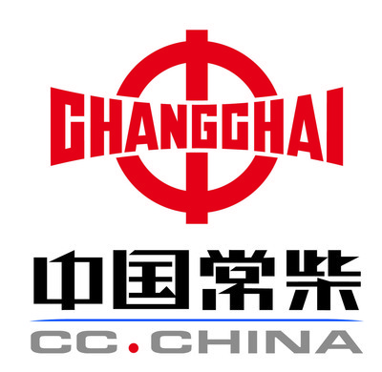

Engine Brand | Changchai 3LS30B
Cooling System | Water Cooling
Cylinders | 3 Cylinders
Rated Power | 22.1KW (30HP)
R.P.M. | 2400r/min

Engine Brand | Kubota V1505-E3B
Emission Standard | EURO III
Cooling System | Water Cooling
Cylinders | 4 Cylinders
Rated Power | 24.5KW (33HP)
R.P.M. | 2800r/min

Model | DY840
Dimension (LxWxH) | 2600 X1240 X 2230mm
Max. reach(boom extended) | 3000mm
Max. reach(boom retracted) | 2480mm
Bucket capacity | 450L
Rated loading capacity | 850kg
Tipping load | 1300kg
Min. turning radius | 2065mm
Turning angle | 45 Degree
Speed | 0-12 km/h
Weight | 1860kg
Standard tire | 26X12-12
Tire pressure | 2.8 bar
Oil tank capacity | 40L
Pressure | 190bar
Working oil flow | 33.5L/minx2
Tracking oil flow | 78L/min
Oil model(mineral oil) | L-HL46
Fuel tank capacity | 23L
Battery | 60Ah, 12V

