MS500 Optional Engines

Engine Model | Kohler CH752
Engine Power/Speed | 27HP/3600r/min
Standard | EPA Tier 4
Engine Type | Gasoline, 2 cylinders, Air cooled

Engine Model | Changchai 3M78
Engine Power/Speed | 21.76HP/3000r/min
Engine Type | Diesel, 3 cylinders, Water cooled
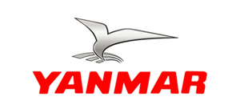

Engine Model | Yanmar 3TNV76
Standard | Euro III
Engine Power/Speed | 25.4HP/3200r/min
Engine Type | Diesel, 3 cylinders, Water cooled

Model | MS500
Moving type | Track or Wheel Type
Dimension (LxWxH) | 1760mm*1100mm*1295mm
Speed | 5km/h
Rated loading capacity | 520kg (including attachment)
Max. Reach | 1800mm
Tyre (Wheel Type) | 6.50-10
Pushing power | 8.2KN
Weight (without attachment) | 1050kgs
Hydraulic oil flow | 30L/min
Track oil flow | 46L/min
Oil tank capacity | 38L
Oil mode | L-HL46
Gasoline oil capacity | 28L/min
Battery capacity | 45Ah
Voltage | 12v

