DY620 Optional Engines

Engine brand | Chinese Changchai 3M78 | Chinese Changchai 3M78-25D
Standard | China stage III | EU stage V
Cooling system | Water cooling | Water cooling
Cylinders | 3 Cylinders/4 stroke | 3 Cylinders/4 stroke
Rated Power | 16KW (22HP) | 17.65(24HP)
R.P.M. | 2800r/min | 2800r/min
Fuel system | Common-rail ,Electrical throttle
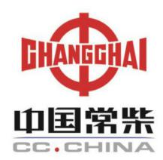

Engine brand | Yanmar 3TNV76 | Yanmar 3TNV76
Standard | EURO III | EURO V
Cooling system | Water cooling | Water cooling
Cylinders | 3 Cylinders | 3 Cylinders
Rated power | 18.7KW (25HP) | 17.6KW (24HP)
R.P.M. | 3200 r/min | 3200 r/min
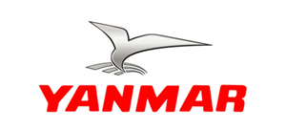

Engine brand | Kubota D1105
Standard | EPA 4,EU V
Cooling system | Water Cooling
Cylinders | 3 Cylinders
Rated power | 18.2KW（24.7HP）
R.P.M. | 3000r/min

Model | DY620
Dimension (LxWxH) | 2195mm*980mm*2150mm
Max. reach(boom extended) | 2750mm
Max. reach(boom retracted) | 2480mm
Bucket capacity | 300L
Rated loading capacity | 500kg-800kg
Min. turning radius | 1980mm
Turning angle | 40 Degree
Speed | 10km/h
Weight | 1100 kg
Standard tire | 23X8.5-12
Tire pressure | 2.8 bar
Oil tank capacity | 35L
Pressure | 190bar
Working oil flow | 33L/min
Tracking oil flow | 50L/min
Oil model(mineral oil) | L-HL46
Fuel tank capacity | 18L
Battery capacity | 55Ah
Voltage | 12v

