TL2500 Optional Engines

Engine Model | YUNNEI YN38GBZ | YUNNEI YN4BL105-30CR
Engine Power | 76KW (103HP) | 77KW (105HP)
Rated Speed | 2400 r/p.min | 2400 r/p.min
Engine Cooling Way | Water cooling | Water cooling
Engine Type | 4 cycle diesel | 4 cycle diesel
Emission Standard | Chinese II | Chinese III

Engine Model | KOHLER KDI2504TCR
Engine power | 55KW(74HP)
Rated Speed | 2600 r/p.min
Engine cooling way | Water cooling
Engine type | 4 cycle diesel Engine
Emission Standard | Terminal EPA Tier 4

Engine Model | Cummins 4BT3.9-C80
Engine power | 60KW (82HP)
Rated Speed | 2000 r/p.min
Engine cooling way | Water cooling
Engine type | 4 cycle diesel Engine
Emission Standard | Euro III

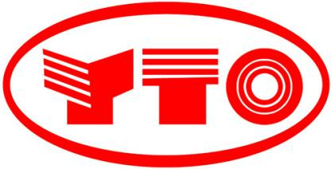

Engine Model | YTO YT4B3-24
Engine power | 60KW (82H.P.)
Rated Speed | 2400 r/p.min
Engine cooling way | Water cooling
Engine type | 4 cycle diesel Engine
Emission Standard | Chinese II

Model |  | TL2500
Engine Details | Engine model | YUNNEI 4102
 | Engine power | 80HP
 | Rated Speed | 2400 r/p.min
 | Engine cooling way | Water cooling
 | Fuel Consumption ratio | 180g/kw.h (standard working condition)
 | Engine type | In-line arrangement, 4 cycle diesel Engine
Overall Dimensions | Overall Length | 5000mm
 | Overall Height | 2800mm
 | Overall Width | 1950mm
Brake System | Service Brake | Four Wheel disk brake
 | Parking Brake | Hand operated
 | Braking Type | Air braking
 | Axle | With hub reducer
Max. Lifting Height |  | 4650mm
Rated Load |  | 2500kg
Transmission System |  | Hydraulic converter+drive shaft+axles
Tyre |  | 16/70-20, OTR Tires, 14ply
Wheelbase |  | 2430mm
Min Turning Radius |  | 5600mm
Track |  | 1470mm
Weight |  | 5500kg
System Pressure |  | 20Mpa
Hydraulic output: |  | 104L/min
Max. Height to the Pin |  | 4500 mm

