DY620E Telescopic Wheel Loader
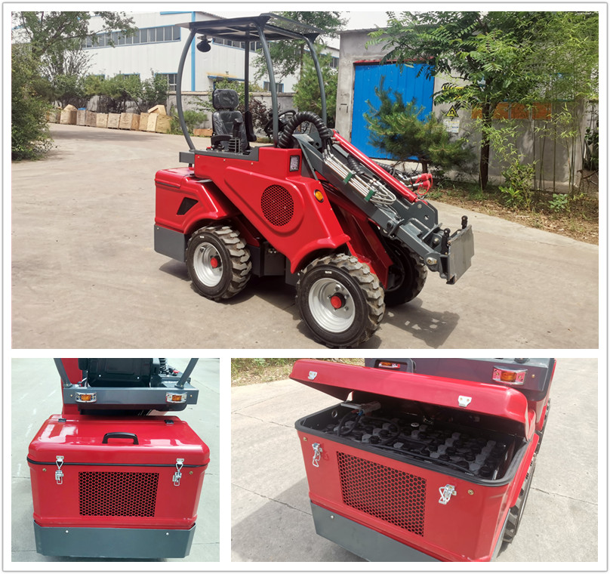
TAIAN electric power mini loader, the DY620E, is a zero emission, low noise and hydrostatic telescopic wheel loader, it’s full-electric drive, battery-powered compact loader, which can perfect to replace fuel machine in multiple working area.
DY620E Features:
- Battery driven, 100% full electric;
- Lead-acid batteries;
- 300 Ah/12kWh battery capacity;
- External battery charger;
- No exhaust emissions;
- Low noise;
- Hydrostatic 4WD;
- Italian PWG brand drive motor;
- Auxiliary hydraulics oil flow max. 30L/min;
- 1 way hydraulic output with 1 electric output on the front;
- Hydraulic oil cooler;
- Telescopic boom;
- Handbrake parking brake;
- ROPS + FOPS canopy;
- 2 front &1 rear LED work lights;
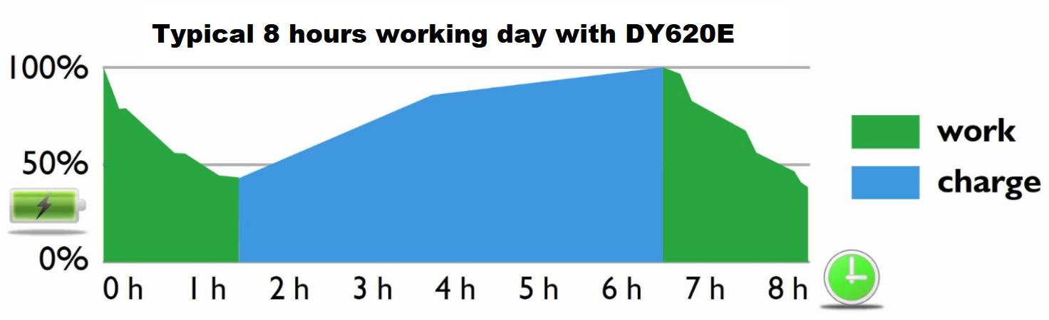

DY620E Specifications
Model | DY620E
Overall Dimensions (L*W*H) | 2390*980*1965mm
Max. Reach (Boom Extended) | 2750mm
Max. Reach (Boom Retracted) | 2220mm
Rated Loading Capacity | 500kg-800kg
Min. Turning Radius | 1980mm
Turning Angle | 40⁰
Transmission | 4WD / Hydrostatic
Speed | 8km/h
Weight | 1500 kg
Standard Tire | 23X8.5-12
Tire Pressure | 2.8 bar
Oil Tank Capacity | 35L
Working Pressure | 180bar
Working Oil Flow | 30L/min
Tracking pressure | 230Bar
Oil Model(mineral oil) | L-HL46
Battery | Lead-acid Battery capacity
Battery Capacity | 12 kWh/300Ah
Power | Electric
Angle of Departure | 25°

DY620E Dimensions
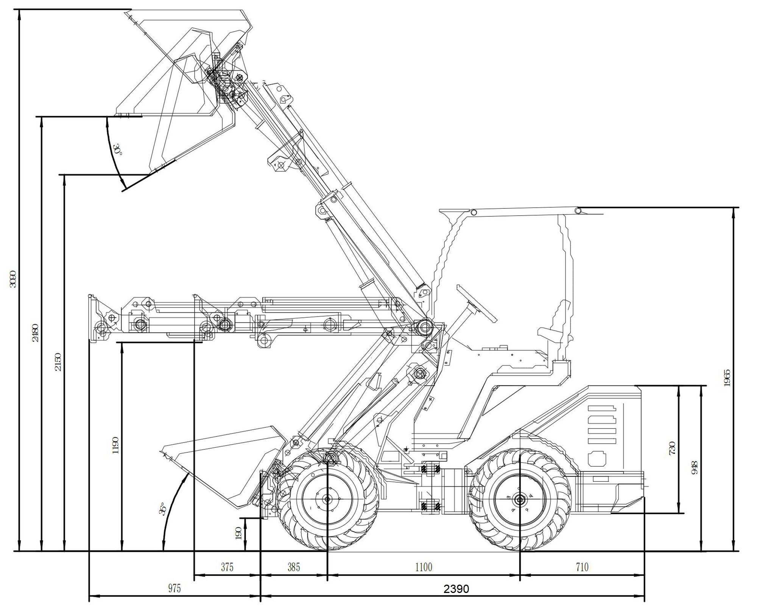

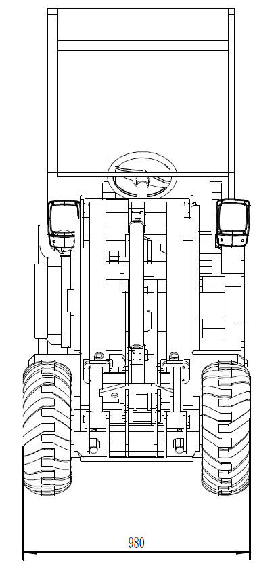
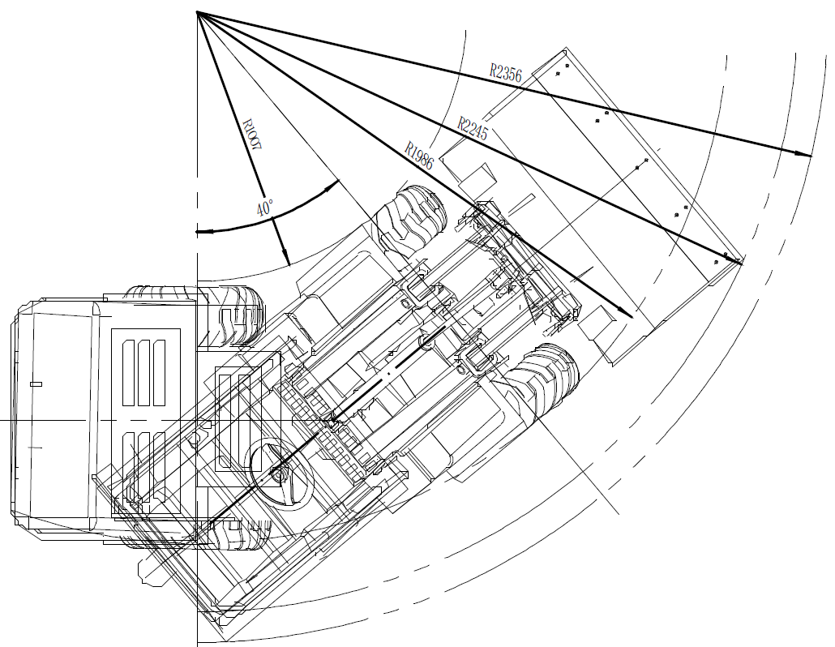

DY620E Optional Cabins:
Steel Proof Canopy | Collapsible Roll Bar
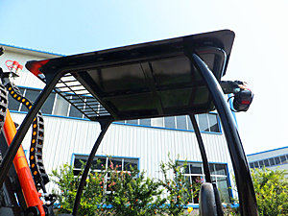 | 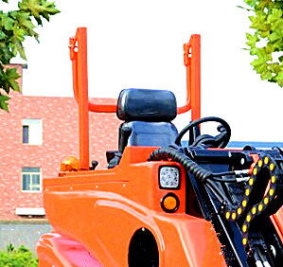

DY620E Optional Tires (23X8.5-12)
Standard OTR Tire | Turf Tire
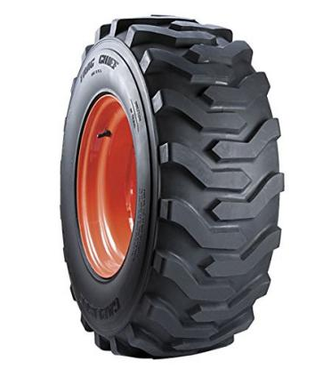 | 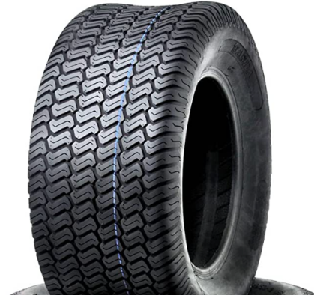

DY620E Other Options:
Trailer hook | 2 Way Multi Coupling Connectors*
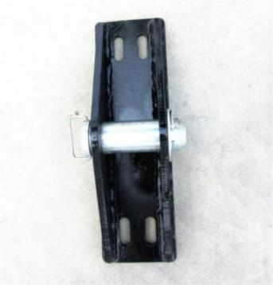 | 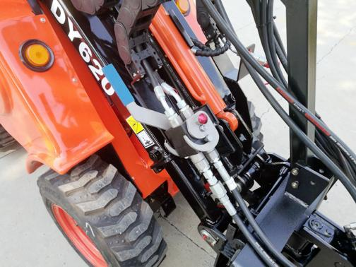

*The information and images in this document are provided for illustrative purpose only and do no bind the manufacturer, who reserves the right to make modifications at any time without prior warning.

REMARKS:
1.Payment:30% T/T in advance, 70% T/T against the copy of B/L; Or irrevocable L/C at sight;
2.Packing:4 sets in 1*20’GP, 8 sets in 1*40’GP;
Or plywood box for 1 set (with additional package costs).
3.Price Valid:30 days.
4.MOQ:1SET.
5.H.S. Code:8429510005.
6.Warranty:1 year or 1000 working hours whichever comes first.

*2-Way Coupling Connectors:
-Convenient and efficient coupling for hydraulic control attachments.
-Both the machine end and the attachments end need to install matching connectors.

