DY50 Wheel Loader
Compact design, low centre of gravity, tight turning radius and powerful performance – these features have characterized the TAIAN DY25/35/50 farm loader lines of products for years and still determine the immense success of the machines. The DY25/35/50 farm loader effortlessly fulfil any work task and work quickly, flexibly and safely – DY25/35/50 farm loader is simply always ready for use.
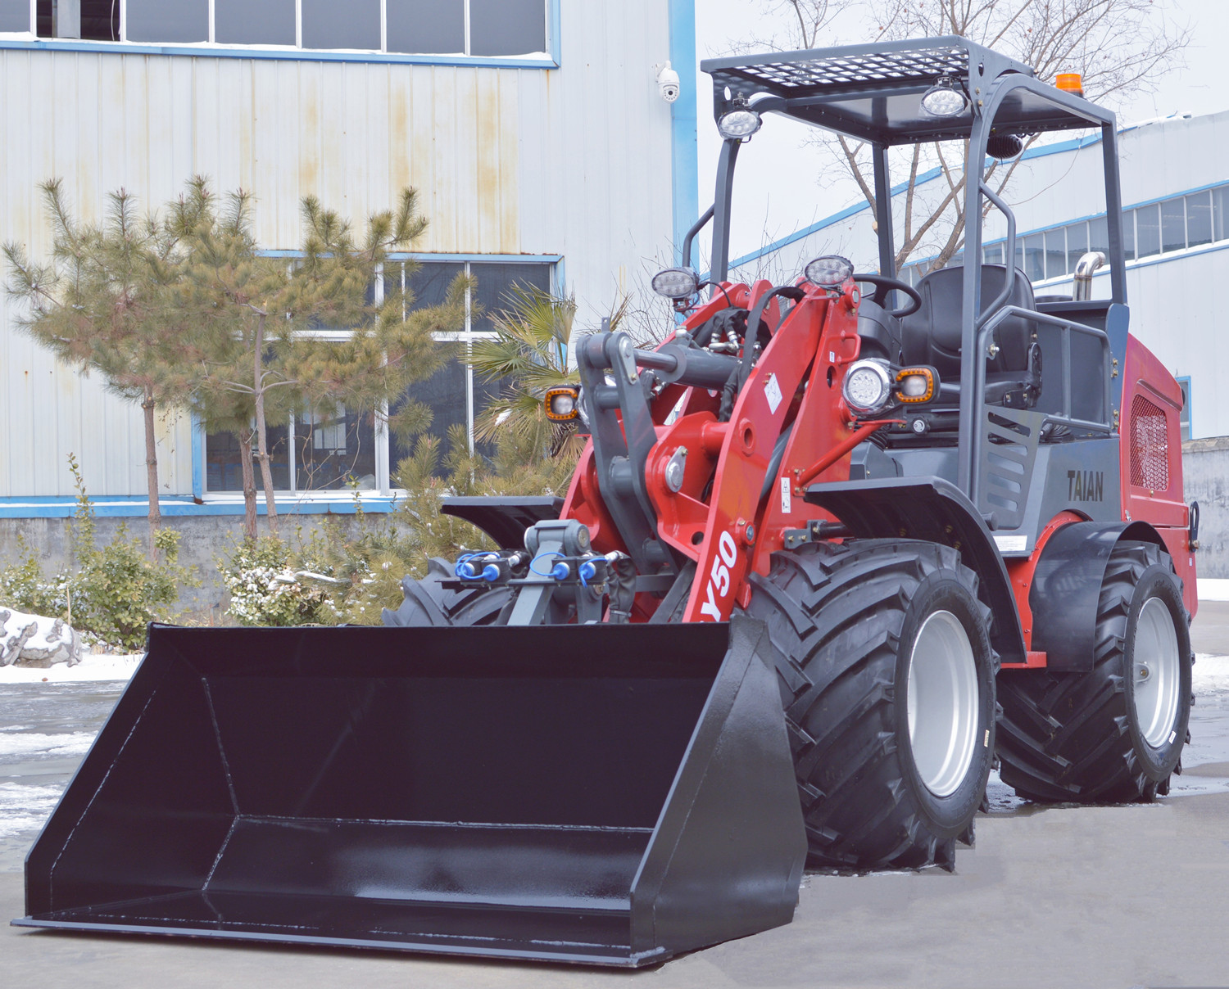
Features:
- Optional Euro stage V / EPA Tier 4 Engine;
- Hydrostatic 4 Wheel Drive;
- CE certified;
- Double Floating Functions;
- Quick Coupling System;
- Hand brake and pedal brake system;
- Side-Tilting Cabin;
- Multiple Attachments for customers’ choice;

Main Components:
- PWG brand driving pump, wheel motor and inch pedal;
- Multi-functional joystick;
- Bucher brand Multi Way Valve;
- Two way hydraulic output on the front end;

DY50 Cabins:
DY50 with Proof Canopy as standard, optional with Closed cabin and Collapsible Canopy cabin. The tiltable cabin design ensure the daily maintenance more easier.
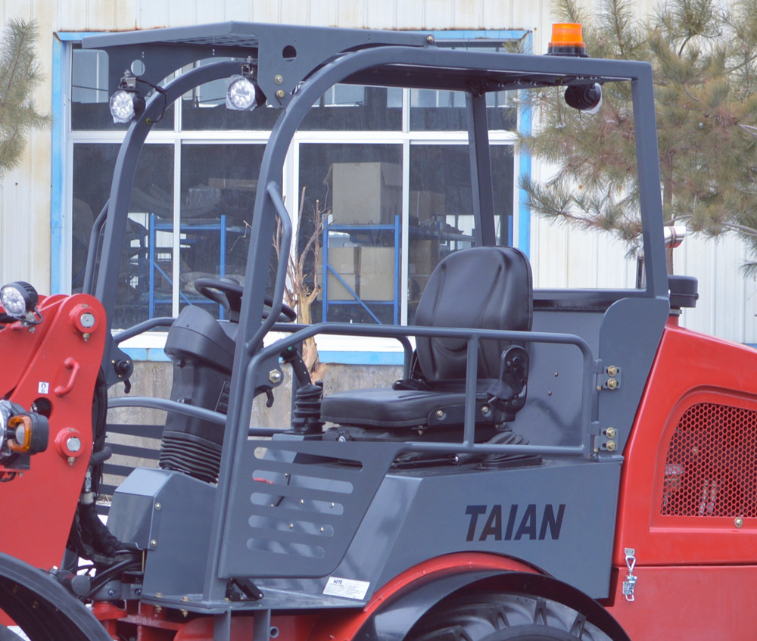

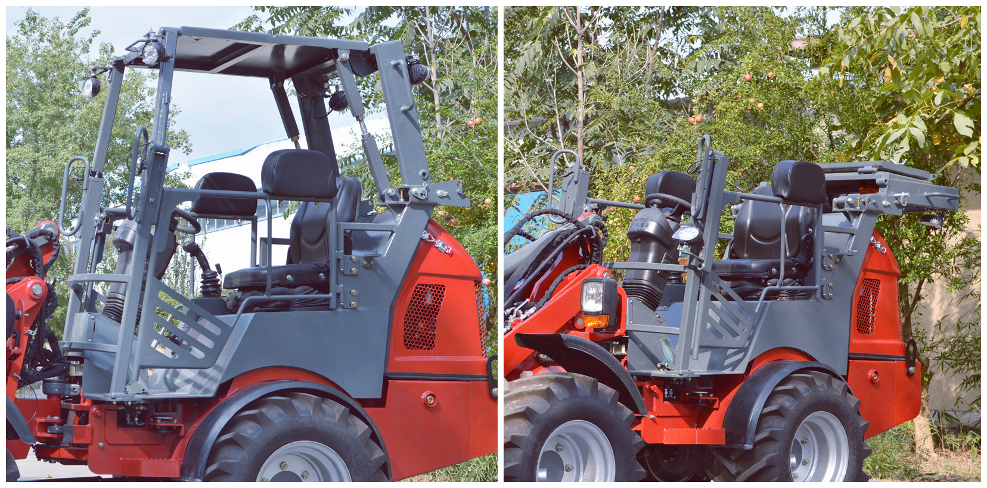
DY50 Optional Engines:
Engine Brand / Model | Yunnei DEF20CDF4 | Yanmar 4TNV88C
Emissions | Euro V | Euro V / EPA Tier 4
Cooling System | Water Cooling | Water Cooling
Cylinders | 4 Cylinders | 4 Cylinders
Rated Power | 45KW (61HP) | 34.3KW (46.6HP)
R.P.M. | 2600r/min | 2800r/min

DY50 Specifications
Model | DY50
Overall Dimensions(With standard bucket): | 4850MM*1560MM*2340MM
Operating Weight (Without Attachment): | 2860kgs
Max. Lifting Height to the Pin (L): | 3264mm
Max.Lifting Force: | 2480kgs
Rated Loading Capacity (Bucket/Forks): | 1400kgs/1250kgs
Tipping Load With Standard Bucket: | 1680kgs
Oil Tank Capacity:
Fuel Tank Capacity: | 50L
Hydraulic Oil Tank Capacity: | 55L
Driving System:
Driving Speed: | 0-10km/H, 0-24 km/H
Type of Drive/Traction Drive: | Hydrostatic Via Drive Shaft
Pressure: | 400bar
Hydraulic Output: | 128L/min
Standard Tires: | 19.0/45-17
Hydraulic Working System:
Hydraulic Output: | 89L/min
Working Pressure: | 180bar
Bucket Capacity: | 0.6CBM

*The information and images in this document are provided for illustrative purpose only and do no bind the manufacturer, who reserves the right to make modifications at any time without prior warning.

DY50 Dimensions
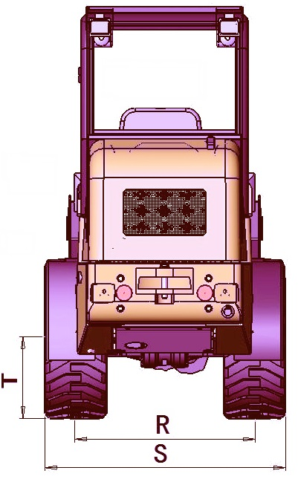
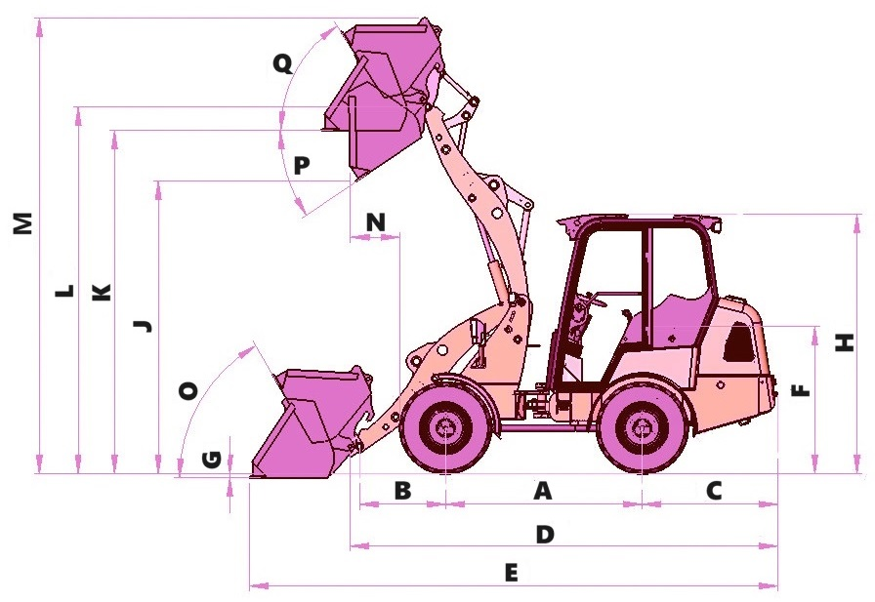
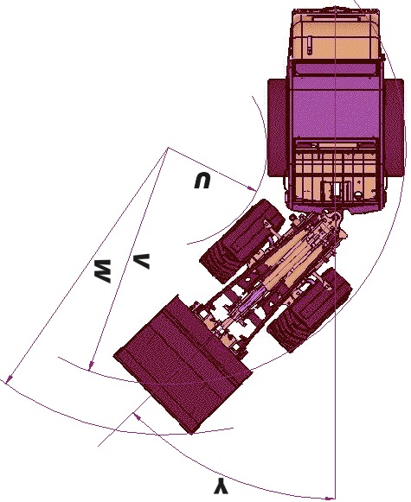

A | 1733mm | E | 4850 | J | 2548mm | N | 441mm
B | 730mm | F | 1360mm | K | 3059mm | O | 47°
C | 1196mm | G | 37mm | L | 3264mm | P | 40°
D | 3779mm | H | 2340 | M | 4036mm | Q | 47°
R | 1120mm | S | 1560mm | T | 252mm
U | 850mm | V | 2460mm | W | 2679mm | Y | 43°

DY50 FOB Qingdao China Unit Price:
With Yunnei Euro V Engine: | USD22600.00
With Yanmar Euro V / EPA Tier 4 Engine: | USD20300.00
Basic Version:
Proof Canopy Cabin: | As standard
Quick Hitch: | As standard
Standard Bucket: | 1PC
Trailer Hook: | As standard
Counterweight: | As standard
Options:
Closed Cabin with A/C system:
Collapsible Canopy Cabin:
Pallet Fork:

REMARKS:
1.HS Code:842951000;
2.Payment:30% T/T in advance, the rest T/T before shipment; Or irrevocable L/C at sight;
3.Delivery time:Within 30 days after receiving the deposit based on engines brand;
4.Packing:1 sets/1*20’GP; 3 sets/1*40’HQ.
5.Price Valid:40 Days.
**********************************************************************

